

Community Content Marketing Action Plan
Framework

Tutorial instructions in this document are courtesy by Content Marketing Institute, Pulse Marketing Agency, Smart Insights and HubSpot.

What exactly is content marketing?
Content marketing is the strategic marketing approach of creating and distributing valuable, relevant and consistent content to attract and acquire a clearly defined audience – with the objective of driving prospect’s action. In short, instead of pitching your products or services, you are delivering information that makes your prospect more informed. The essence of this content strategy is the belief that if we, as initiators/public managers/policymakers, deliver consistent, ongoing valuable information to prospects, they ultimately reward us with their business and loyalty.

Why you conduct community content marketing?
Your community content marketing placed on different channels is aimed to narrow your prospects attention and bring them to your community economic development website. The major objective is to convert them from prospects considering doing business, or moving to your community, into visitors and then into real costumers.

Some examples of content marketing:
- videos
- webinars
- on-line presentations
- e-books
- white papers,
- case studies,
- blog posts,
- infographics,
- checklists,
- others

Where to begin?
- An understanding of your goal(s)
- A mission statement
These two elements are key, not only because they help you decide what content you should be creating, but also because they are great lenses through which you can examine content projects from an enterprise perspective and figure out if there’s something in particular that you should not be doing.

Your content marketing mission statement

YOUR CONTENT MARKETING GOALS

Content should never be created for its own sake. Rather, it needs to support at least one core marketing or business goal. Consider the ways you would like a proposed piece of content to help your business. For instance, your content marketing goals may be:
- To raise awareness for your brand
- To build your email list
- To nurture prospects (business & talent) along their decision-making journey
- To convert your audience (site selectors/ company reps/ tourists/migrating citizens) from prospects only considering your place to prospects visiting your place
- To retain customers (business & talent) and/or increase their “purchases” (up-sell/ cross-sell

Remember to constantly ask yourself, “How will this project support our business goals?” If you find that the content you have planned will not support those goals, chances are that it should not be a priority.

Define your community content marketing goals:
……………………………………………………………………………………………………………………………………………………………………
…………………………………………………………………………………………………………………………………………………………………..
……………………………………………………………………………………………………………………………………………………………………
……………………………………………………………………………………………………………………………………………………………………

The mission statement outlines 1) the reason for your content marketing, and 2) the priorities & perspectives it upholds in pursuit of that mission. As such, it should speak to three components of any successful marketing endeavor:
- The core audience target: The type of prospects you can help most with your content (refer to your Community Marketing Strategy chapter 3 “Target groups and key messages”)
- What will be delivered to the audience: The types of information you will provide through your content
- The desired outcome for the audience: Things your audience will be able to do once they have consumed your content
Hint: Your audience should never be “everyone” — even if you can find a use case for everyone. Be as specific as possible, and then get to know this person as well as you can. You may have a few different audiences you plan to target with your content, and that’s perfectly fine. If you’re wondering where to “draw the line,” consider whether their informational needs are different. If they are, you will likely need to consider them separately.

Define your Content Marketing Mission Statement:
………………………………………………………………………………………………………………………………………………………………..
…………………………………………………………………………………………………………………………………………………………………
………………………………………………………………………………………………………………………………………………………………….
………………………………………………………………………………………………………………………………………………………………….
…………………………………………………………………………………………………………………………………………………………………..
…………………………………………………………………………………………………………………………………………………………………..

Target Personas and content mapping:

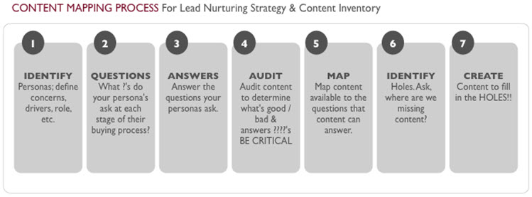
1. Identify the questions your target personas (all target groups) have for each stage of the decision-making process

While this process may vary for different prospects, it can be broken down into six basic stages:
- Early stage
- Early (mid)
- Early (late)

- Mid stage
- Mid (late)

- Late stage

1.1. How to identify (research) the questions your target personas may have:

1.1.1. Interview current customers
Your current customers are a perfect resource because they’ve purchased your product or service and are relatively accessible to you. Interviewing customers will not only give you insight into their decision-making process, it will also be a great opportunity to gather content for a case study. An easy way is to leverage new relationships: try asking a couple of probing questions about their purchasing process at the end of your initial kick-off meeting. In addition to talking to customers one-on-one, also consider surveying prospects or conducting focus groups.

1.1.2. A/B testing

Test messaging, frequency and headlines, but you should also be testing different types of media. What content formats are most effective? If you can take it a step further, test content with groups at different stages of the decision-making process.

1.1.3. Try progressive profiling
Leverage repeat traffic to your site to gather more information about prospective buyers. It is a perfect opportunity to analyze key trends gleaned from the data that these prospects provided to you over time.

1.1.4. Study your web analytics
There’s a ton of data accessible to you through your web analytics, and learn more about your buyers?
- What are the patterns of visitor behavior?
- Where do they come from?
- Where do they go while on the site?
- How long do they stay?
- What content formats are most popular?
These patterns tell you anything about where your customers are in their buying process, or what content is most effective at the different stages of their buying process.
Use Google’s keyword suggest tool to better understand how prospects describe their challenges.

1.1.5. Leverage your competitors
Study the research or case studies that your competitors have published. Reviewing their case studies might help you better understand your buyer, as well as why they chose your competitor over you. In addition to following the competition, follow industry analyst blogs and reports.

1.1.6. Use professional social networks
Aside from the major professional networks (like LinkedIn), try to find other, industry-specific networks where your buyers might be. These networks are a great opportunity for listening and engaging. They will help you to better understand the daily challenges or successes your prospects have and in many cases, give you the opportunity to ask questions of that community and get real, thoughtful responses. These networks are also a great way to enhance the data you already have about people, and see how they are connected to other people within their own organizations or whom you know.
Examples:
- EFactor
- Gadball.com
- Biznik
- Spiceworks
- BranchOut
- ProScore
- BeKnown
- StartUpNation
- Ziggs
- Ryze

1.1.7. Go to events
There are a lot of ways to get information about your prospects at events:
- Have discussions with prospective buyers
- Get great insights through presentations and panels, including listening to the answers the audience gives when speakers ask questions
- Learn how your prospects are doing things (what technologies or methodologies they are using)
- See what your competitors are doing with their customers.

2. Be ready with the pillars for your content

As part of your strategy, you will need to determine what your “pillars of content” — in essence, the stories you want to tell — will be. This will be more of a framework than a fully realized to-do list or template, as its purpose is to help you to develop the best way to tell your story (or, perhaps, to help you discover what’s missing from your community’s existing story).
2.1. Your community brand story (refer to Instructive Documents “Community Brand Concept”)
2.2. Your community advantages & assets (refer to Instructive Documents “Community Unique Value Proposition”, “Instruments for Improving Community Attractiveness”)
2.3. Blend together the questions which your target groups may be asking (above) and the information about your community which you want to promote, develop your community marketing content
3. Answer the questions which your prospects ask at different stages of decision-making process:

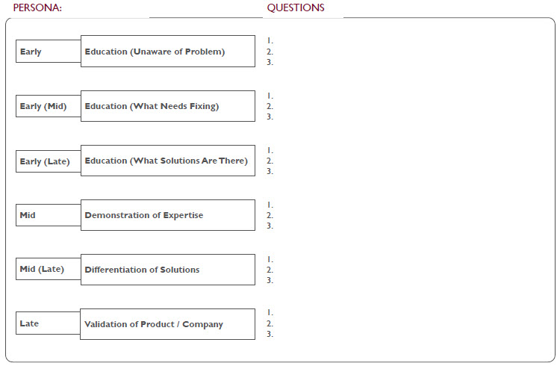

4. Create your Content Matrix: Questions, Answers + Content Formats
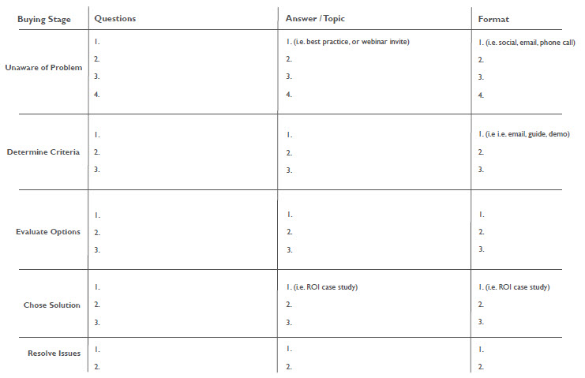

5. Conduct a content audit and build the Content Inventory

Next you want to do, based on Content Matrix, is to build Content Inventory. This will help you visualize what you are trying to do with the content mapping and storing of content that’s easily accessible by anyone in your organization to support individual communication processes in all departments.

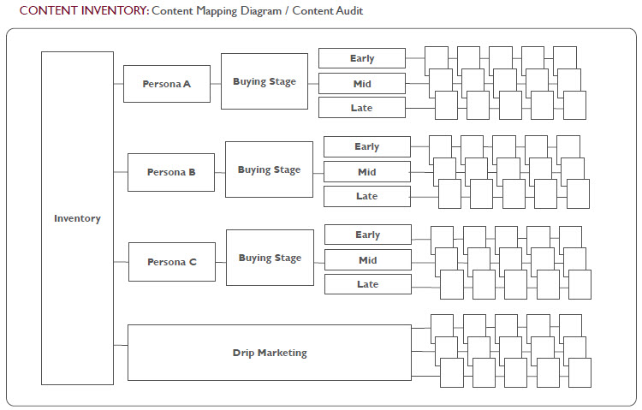

6. Map the content

Now you need to map the content (as shown above) you will use for each persona at various stages of the decision-making cycle. When you map your content this way, you will probably find that you have a lot of content for a certain stage or certain persona. This is good; it gives you a very clear place to start filling in gaps.

7. Identify content gaps and create content

The gaps are the holes you have left that need to be filled. Knowing the gaps will help you prioritize the work, but it will also help you be better informed if a partner or media opportunity arises. You’ll know if you should spend the time and resources on it or not. Also, when you develop the content, be sure to address your target persona’s information consumption needs, and desired content formats at different stages. This process isn’t just about knowing what to send out next, it’s about understanding what your prospects want, and being relevant, helpful and valuable to them.
8. Define how your prospects consume content

- Do they attend events? In-person or online? How frequently?
- Do they subscribe to RSS feeds?
- Do they like email newsletters?
- Do they access content online or via a mobile device?
- Do they get most of their information during work hours or at home?
- Do they get their information through word-of-mouth from their business community?
- Does advertising play a role?
- What content are they consuming?
- Why are they consuming that content?
- What format is their preferred content in?
- Who do they get their content from? Industry analysts, vendors, thought leaders, friends?
- Is the content they need to make a decision different from their primary interests?
- How often are they exposed to new content/information?
- How often do they log on to social networks? Which ones?
- How much content do they consume at different stages of their buying process? Do they need more at the early, mid or later stages of buying?
- How does the format of content they consume change throughout the buying process?
- Are there internal/external influences in the kind of content they choose to consume? (Does an internal event trigger certain content consumption? Does the community itself drive the content needs/expectations of individuals?)

9. Define your content marketing formats

9.1. Frequency depending on resources
Start by determining how much of a commitment you plan to make to content creation. Do you have the team resources to publish new content on:
- daily basis,
- weekly,
- monthly,
- quarterly timetable
While all content marketing programs need to be consistent, there are certain content tactics that work best if you can deliver new content frequently and on an expected schedule. If you are unsure that you will be able to meet a predetermined schedule on an ongoing basis, it’s best to avoid those content formats (blog or news-focused email newsletter, for example).

9.2. Frequency depending on the format
Here is a quick look at how consistent you need to be with certain kinds of content. This list is not meant to dissuade you from trying new things; rather, it is meant to encourage you to commit to formats that require consistency — and experiment more with tactics that aren’t as tied to particular frequency expectations (although you will likely get better results.)

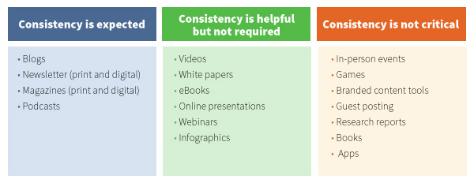

10. Define content marketing topics

Not only do you need to figure out what formats work best, you also need to decide what topics to cover when creating content in those formats. In the actions above you’ve discovered what your audience cares about and what makes sense for your business. While it’s wise to research your audience to figure out what kind of content (both formats and topics) they are most likely to respond well to, you’re not going to know what works for your particular case until you start trying. Don’t be so paralyzed by perfection that you don’t publish anything at all. Look for the middle ground: What can you do to make incremental improvements to your program?
Here are some examples of possible approach to topics selection for content marketing:
- Consider that maybe less content will mean more impact.
- Find at least three thought leaders in your organization and build them into your content plan.
- Define your most valuable audience and consider a targeted print publication.
- Assign one employee to SlideShare and figure out how to leverage this tool as part of your content marketing.
- Develop a series of stories for your industry on an aspect that has never been covered before.
- Make sure that every content landing page for has only one call to action.
- Write your book.
- Update your social media influencer list before the end of the year.
- Compile a substantial piece of influencer content (i.e., an eBook of influencer insights) in this year.
- Get at least five employees who are not in marketing involved in your weekly content plan.
- Make it a priority to personalize your content by persona in 2013.
- Start a podcast series for executives.
- Sit down with every salesperson and ask them what their customers’ biggest pain points are.
- Develop a list of the top 100 questions coming from your customer base.
- Commission a piece of art from a local artist to use in your next content piece.
- Target one traditional marketing initiative that can be enhanced with content marketing.
- Set a goal for the year to double the number of email subscribers to your content.
- Read one non-marketing book each month during the year (it will open up new content marketing ideas).
- Stop doing the same old press releases and create them as engaging stories.
- Find a way to work with the leading trade magazine in your niche on a joint content effort.
- Commission a piece of research that is important to your customers.
- Take research findings and use them to build a six-month campaign with at least 20 independent content pieces.
- Commit to smarter usage of images in your content in the year
- Do an audit of all your blog posts and determine which types of titles lead to the right reader behaviors.
- If you have the budget, start identifying media companies in your industry that may be ripe for acquisition.
- Make sure your content is easy to read on both smartphones and tablets.
- Set up an editorial leader in each of your silos and plan to meet at least once per week.
- Develop a customer event that doesn’t talk about your projects, but rather educates them on where the industry is going.
- Create a piece of content that would be completely unexpected and see what happens.
- For every story idea you have for next year, plan on developing 10 pieces of content from it.
- Send a videographer and journalist to the next industry event and cover it.
- Give out quarterly awards to all internal content creators based on number of content shares. Make it public.
- Choose 10 of the top bloggers in your industry and sponsor a one-day brainstorming session on how you can all help each other.
- Ask whoever is in charge of customer service what their top 10 complaints were last year. Build a content program to help with answers.
- Whatever you do this year, make sure you are telling a different story than everyone else in your industry — not just the same story told incrementally better.
11. Define the channels you want to use for your community content marketing
For details about your Social Media Content refer to Instructive Document 9.2. Community Social Media Marketing
Facebook
- Facebook Pages: The most commonly trodden path for marketers on Facebook are good old fashioned business pages
- Facebook Instant Articles: Blogging and text in general are still the main drivers of content marketing. The bottom line is, people like to read. Hence, using Facebook Instant Articles to publish short articles similar to those that might be found on Medium or LinkedIn Pulse is a great way to build a Facebook following
- Facebook Groups: Facebook users set up groups to discuss ideas, movements, hobbies, brands and everything in between. Find a group relevant to your niche, join it and then (tastefully) use your content to add value to the conversations
- Facebook Ads: To promote your content further on Facebook, consider boosting the posts on your Facebook page or checking out the Facebook Ad Manager

Tweeter
- Twitter Direct Messages: The power of direct messaging is underestimated, particularly in B2B situations
- Twitter Moments: If you're posting a series of tweets, perhaps because you’re live-tweeting an event, you may wish to create a Twitter Moment, which is essentially an easy-to-digest slideshow of tweets you select
- Twitter Ads: To get your content in front of more people, you can craft a Twitter Ad to funnel people towards your Twitter profile or website

Instagram
- Instagram Direct Messaging: Similar to Twitter direct messaging, you can reach out to your audience on an individual basis in order to provide added value. Ideal for B2B content marketers
- Promoted Content: Instagram allows you to sponsor specific posts, helping you reach a broader audience

Linkedin
- LinkedIn Pulse Articles: LinkedIn allows you to publish fully fledged articles within their ecosystem. Ideal for sharing opinions and announcing news
- LinkedIn Groups: Similar to Facebook Groups, you can join LinkedIn groups relevant to your niche and get involved in the conversations
- LinkedIn Ads: Like Facebook, Twitter, Instagram and Snapchat, you can help yourself to LinkedIn’s ad manager to spread your brand’s message further

Other professional social media
- EFactor
- Gadball.com
- Biznik
- Spiceworks
- BranchOut
- ProScore
- BeKnown
- StartUpNation
- Ziggs
Print, radio, TV advertisement channels
12. Build your editorial calendar
(courtesy by HubSpot)

Often, the greatest challenge of content marketing is not the actual writing. It’s all the other related tasks, let it be brainstorming topics, targeting the right readers, or optimizing posts with the best keywords and calls-to-action. Yet, each of these steps are necessary to be organized, focused, and ultimately, successful. Use the template 9.3.1. Blog Editorial Calendar to organize your editorial activities

Use these steps to create your editorial calendar (courtesy by Pulse Marketing Agency):
- Decide how often you will publish
Publishing blog posts weekly or twice-monthly is likely sufficient. eBooks or white papers might be best suited for quarterly or biannual publication. Frequency and content type will depend on your audience, goals, and budget.
- Make a list
Make a list of the things that must happen to get a piece of content published after you’ve assigned it to an author or subject matter expert. If you’re writing in-house, those steps include research, writing time, editing/ review, proofreading, and publishing. Make room in your calendar for all of those things.
- Assign an author to each piece
Remember that your colleagues are already busy with their regular jobs; for them, contributing to your content marketing effort is just one more thing to do. Hiring a solid freelancer or a reputable content marketing firm to write can be a lifesaver.
- Work backward from your publication date, assigning deadlines for each step
Make sure you include time for research and creating an outline. Both are critical steps. Remember that if you are publishing frequently, deadlines will start to happen simultaneously, which is why it’s so vital to stick with your schedule.
- Assign publication dates
Publish regularly, and be mindful of holidays. Resist the temptation to just “go dark” during busy times, vacation season, etc.
- Keep track of everything SOMEWHERE
This isn’t really part of the planning and scheduling but it’s important. Make sure you put ALL of your content into your calendar, choose some type of calendar tool to track it all, and update it frequently. Which platform you use isn’t vital, but you need to use something.
13. Write a business plan for content marketing

In order to secure resources for your Community Content Marketing, you will need to develop a business plan and present it to community decision-makers. Use template 9.3.2. Community Content Marketing Business Plan
Notes:

